**Forest Fire Detection and Prediction from image processing using RCNN**

**Abhay Chopde1, Ansh Magon2, Shreyas Bhatkar3**

1Vishwakarma Institute of Technology  
666, Upper Indira Nagar, Pune, India

abhay.chopde@vit.edu

2Vishwakarma Institute of Technology  
666, Upper Indira Nagar, Pune, India

ansh.magon19@vit.edu

3Vishwakarma Institute of Technology  
666, Upper Indira Nagar, Pune, India

shreyas.bhatkar19@vit.edu

***Abstract*-** Forests are the most important part of terrestrial life as they provide shelter to 80% of terrestrial life and provide them with food as well. Forest fires are a serious threat to flora and fauna followed by deforestation. Various preventive measures are taken to avoid such incidents from taking place still, many such incidents happen every year causing long term damage to surrounding biology, environment, and wildlife. This paper proposes a large-scale monitoring system and deep learning-based forest fire detection model that can detect forest fires from video frames captured by UAV drones. The proposed CNN model successfully detects forest fires with 97.29% accuracy. This will help to control the forest fires before they get out of control.

***Keywords*: F**orest Fire prediction, RTH index, RCNN, UAV

**1. Introduction**

Forests are the reason for most of the earth’s terrestrial biodiversity. Forest is an ecosystem that provides food, shelter to 80% of the living beings on the earth. Most of the time homo sapiens have existed, spent their lives in the forest. They play a crucial role in weather, atmosphere, rains and other various ecological factors important for the existence of terrestrial life. Forests are the largest terrestrial storehouse of carbon (and thus fuel). They are still home to many indigenous tribes. Around 60 million people are from various indigenous tribes around the globe. The area covered by forests has been shrinking due to deforestation.

Forest fire is another threat to forests. Forest fires exist since the forests exist themselves. Forest fire is uncontrolled in vegetation more than 1.8 metres (6 feet) in tallness. These shoots frequently arrive at the extents of a significant blaze and are now and again started by ignition and hotness from surface and ground fires. A major woodland fire might crown-that is, spread quickly through the highest parts of the trees before including undergrowth or the timberland floor. Accordingly, fierce blow-ups are normal in wood flames, and they might expect the attributes of a firestorm. The natural cause of forest fires is mostly lightning or high atmospheric temperature and dryness. Human activities like spillage of crude oil or inflammable substances can also cause forest fires to start.

Respective authorities implement various preventive measures to avoid forest fires. Tourists are also provided with instructions like selecting an open location for forest fire and extinguishing the fire completely before leaving. Still almost every year several incidents of forest fires take place. This indicates that prevention alone is not enough to avoid such incidents. Forest fires spread varies directly with factors like flammable materials available, speed of the wind, weather conditions etc. All these factors work in favour of fire, then in the very short period it covers a huge area.

To avoid this paper proposes a deep-learning-based forest fire detection model that can detect the forest fire from satellite images.

**2. Literature Review**

This work [1] deals with the analysis of existing wireless systems for forest fire detection. The paper provides a clear understanding of the limitations of various wireless sensors for detecting forest fires. It deals [1] with the advancement of forest fire detection systems, the importance of detecting forest fires and how to utilise power efficiently. The energy that is dissipated during the transfer of signals is directly proportional to the distance between the sensors. Thus, the strategic spacing of sensors is required. Another important aspect is the integration of data. All the sensors [1] must collect as much information as possible and transfer it to the monitoring systems. This way speed and energy are efficiently utilised. This work briefly highlights the classification of energy-efficient protocols in the fire detecting system. Fault tolerance is important for a fire detecting system. Due to network dynamics, the sensors are prone to error. For this, the use of fault dragonizing protocols must be used.

Dealing with actual forest fire systems, [1] provides the actual implementation of such a system. This work utilises a wireless network of sensors, radio wave attenuation and wireless communication protocols. This is a cluster-based network for detecting fires in real-time. An interesting fact that the paper [1] presents is that complex conditions, vegetation, dense green forest cover, leads to the deformation of the sensors. These factors also influence the transmission of the signals to form one sensor to the other. Here the utilisation of a cost function is made. It determines the effective spacing between sensors for optimum communication [1]. Therefore, effectively utilising resources and power consumption.

More on real-time systems for detection of fires, [2] provides the effective usage of the wireless systems. This paper proposes the utilisation of various small nodes spread over large distances in the forest. Though such an approach requires a lot of maintenance with the use of fault diagnosis and tolerance, this system becomes efficient. The approach followed here [2], is proved to be faster and easy to scale. It has economically made use of the energy of WSN’s (Wireless Sensor Networks). The primary purpose of such a system is to provide an early warning of a fire. This system [2] also has the capability of providing the details of the fire, how widespread the fire, its intensity, and many other factors.

The use of a light detection system comes in handy as well. In [3], the paper proposes the use of a light detection system. Such a system is cost-efficient and fast. Here [3], the use of HSV and YCbCr colours [3] have been used. Providing the ability to differentiate between various colours. However, detecting colours along with detecting high brightness intensity and ambient colours. The size of the fire is calibrated using frame differences. The alarm has been attached [3] to such a system, whenever a fire is detected an alarm ring. The alarm rings are subjected to a few conditions mentioned in the paper [3]. The overall accuracy of such a system is greater than 90% in all cases.

Using a neural network for the detection of forest fire in another approach. This work [4] uses a neural network to detect forest fires. For warning, an alarm is integrated within this system. The paper [4], covers the design of the circuit in detail. The circuit comprises temperature sensors, a microcontroller that works the neural network, CO sensors [4] and photoelectric sensors. The neural network utilises the technique of backpropagation [4] for effective classification with higher accuracy. This approach [4] has further enhanced the backpropagation technique, integrating it with the Levenberg-Marquardt algorithm. Testing is done on simulating software.

Using computer vision and smoke sensor detectors together is an interesting approach. This hybrid approach [5] is accurate and smarter. Vision-based classification [5] runs its course first, its goal is to reduce the false positivity rates for effective classification. Afterimage processing technique the smoke detector detects any combustion. This hybrid approach has a satisfactory approach of 87% accuracy. Using a two-step verification process [5] makes this model reliable despite lower accuracy. The entire integration of all sensors is done using a web server and Raspberry Pi microcontroller. This way communication between sensors is speedy and efficient. The architecture of the entire system is versatile and void of loopholes.

An automatic system for fire detection is discussed here [6]. This system comprises various parts. A fire alarm, fault diagnosis system, integration of components [6] using protocols and servers. It has followed a straightforward approach, using a smoke detector, if there is combustion then the alarm is triggered.

An IOT-based approach is followed in [7]. The primary purpose of following use of this approach is to reduce the wiring and increase its wear and tear. Thus, the implementation of IoT. Here [7] numerous nodes are used. Each node comprises a microcontroller, temperature sensor, CO sensors (Carbon Monoxide). All nodes are interconnected with the help of a Wi-Fi network. The Wi-Fi network tackles [7] the wire situation efficiently. For faster and more accurate transmission, the system uses a GSM module for alerting for the fire. Thus, eradicating the use of alarms which may deteriorate [7] over time. Thus, here a mobile application has been used which displays the information about the fire.

This paper [8] goes through the design and implementation of a fire detection system. It overcomes the drawback of using WSN (Wireless Sensor Networks). WSN’s work for a particular spot does not cover a large spread of areas. Thus, the use of image processing [8] with a suitable machine learning algorithm is more accurate and reliable [8]. Fault diagnosis and tolerance is highly efficient for such a system [8]. The possibility of malfunction of sensor or network doesn’t impact this system. For real-time application, the input [8] is taken from a camera, the working is done on each frame thus making it robust and adaptive. This work [8] is tested in a controlled environment giving an excellent result. The accuracy of the model is found to be 93%.

**3. Methodology**

The proposed system can be set up in forest areas prone to annual forest fires as it predicts the chances of fire as well as identifies and confirms the presence of fire. To monitor an entire forest area, a considerable number of nodes are established to check environmental factors. On the confirmation of fire, it transmits the message to the nearest node so that the concerned authorities can act.

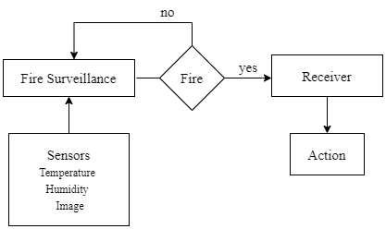

Fig. 1: Overview of Forest fire monitoring system

Fig.1 shows the overview of the overall forest monitoring system

.

Fire surveillance system verifies the presence of fire by monitoring temperature and humidity data and video frames captured by autonomously flying UAVs (Unmanned Ariel Vehicle).

**3.1. Monitoring of temperature and humidity**

As mentioned earlier, temperature and humidity are the 2 most important factors which describe the characteristics of the forest’s environment before an early forest fire.

Initially, monitoring of temperature and humidity is done by obtaining temperature and humidity data through sensors.

DHT11 is a temperature and humidity sensor with calibrated digital output, and it is connected to the analogue pins of Arduino Uno. The value of temperature is measured in terms of Celsius and humidity is measured in terms of relative humidity (RH). The relative humidity is the ratio of the amount of water vapour and its saturation point. Generally, temperature and humidity are inversely proportional as fire causes rising temperature and dry and smoky air.

If the temperature is above a certain threshold and humidity is below a certain threshold, it’s the indication of a potential forest fire threat. This threshold value may vary concerning each geographical region.

Based on the relation of temperature and humidity the presence of an early forest fire is estimated.

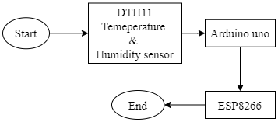

Fig. 2: Fire surveillance for monitoring temperature and humidity data.

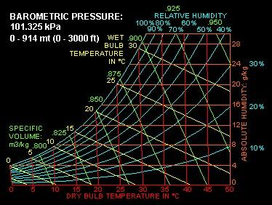

Fig. 3: Temperature and Humidity relation

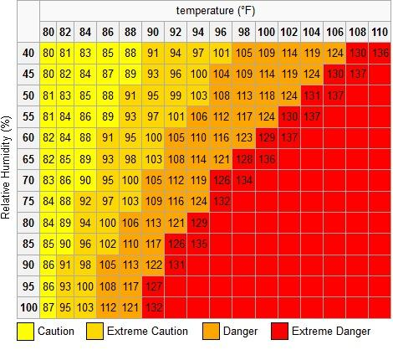

Fig. 4. Heat-map of threat level, shows a grid table with respective gradient scales of each threat level corresponding to a certain temperature.

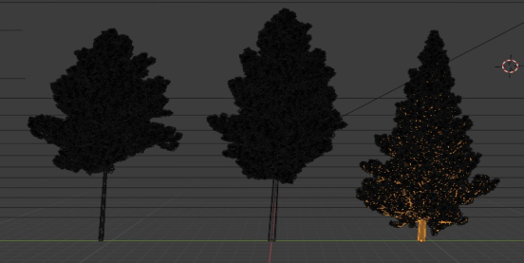 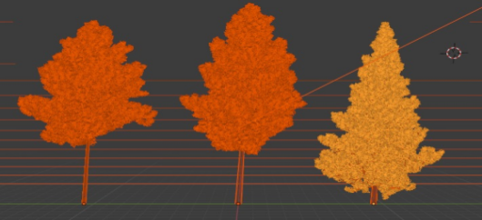

1. (b)

Fig 5. RTH indexing of the surrounding environment, (a) low RTH values, with low risks. (b)

High RTH values, higher risk level.

Apart from predicting the fire, it also performs graphical monitoring. As the temperature and humidity alone cannot verify the forest fire, there is the need for a solid proof of the arrival of an early forest fire. The simulation was made to demonstrate the state of urgency according to the temperature and humidity factors of the area under surveillance. The tints show the representation of the fire and the corresponding threat levels. The actions would be further taken when the threat level rises beyond the par value.

**3.1. Fire Verification**

After the suitable environmental conditions for fire ignition are spotted, the UAVs are sent to confirm the fire’s presence. UAVs are mounted with CMOS cameras capturing video images with 30fps. The aerial and semi-aerial view of the area under the concerned node is captured. The verification of fire is done using the RCNN model which correctly spots the fire.

The dataset was created during the NASA Space Apps Challenge in 2018, the goal was to use the dataset to develop a model that can recognize the images with fire. It consists of over 999 images divided among 2 classes. The main advantage of using this dataset is, it is skewed, that is both the classes contain a different number of images.

It contains 755 outdoor-fire images, some of them contain heavy smoke and the remaining images contain 244 nature images (eg: forest, tree, grass, river, people, foggy forest, lake, animal, road, and waterfall) without fire.



Fig. 6: consists of 2 classes, (a) is Forest affected with fire, (b) is a forest without fire.

To make the dataset immune to overfitting, several data augmentation techniques like flipping, rotation of 300, brightness enhancement through different scales, zooming, shearing were performed on images.

Many deep learning models effectively deal with challenges in computer vision like occlusion, noise, clutter, flame smoke variation, illumination variance, and view-point issues. Initially, the training data was fed to the CNN model.

Artificial intelligence has grown dramatically in its ability to bridge the gap between human and computer capabilities. Researchers and hobbyists alike work on many facets of the discipline to achieve spectacular results. The discipline of machine vision is one of several such topics.

The goal of this field is to allow a computer to perceive the world in the same way that humans do and to use that knowledge for a variety of tasks such as image and video recognition, image processing and categorisation, mainstream press recreation, recommendation engines, computational linguistics, and so on. Deep Learning improvements in Computer Vision have been built and developed through time, particularly over one specific method - a Convolutional Neural Network.

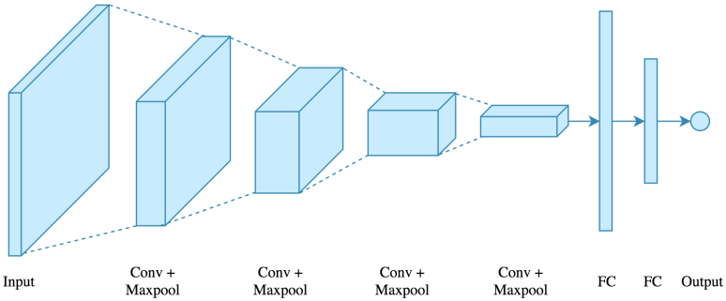

Fig. 7: An overview of the CNN model

A Convolutional Neural Network (ConvNet/CNN) is a Deep Learning algorithm that can take in an input picture, give importance (learnable weights and biases) to distinct aspects/objects in the image, and discriminate one from the other. When compared to other classification methods, the amount of pre-processing required by a ConvNet is substantially smaller. While filters in primitive approaches are hand-engineered, ConvNetscan learn these filters/characteristics with adequate training.

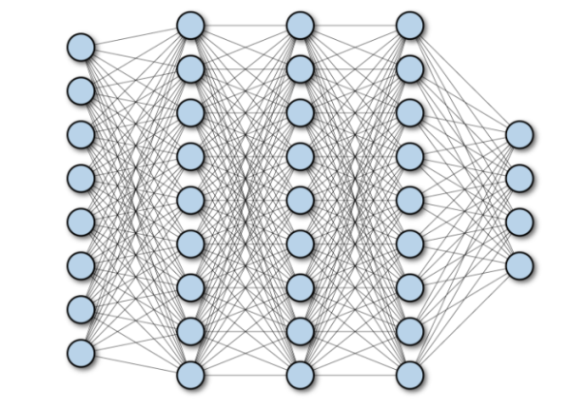

Fig. 8: A network depicting fully connected layers in CNN.

Image analysis has various difficulties like order, object identification, acknowledgement, depiction, and so on If a picture classifier, for instance, is to be made, it ought to have the option to work with a high exactness even with varieties, for example, impediment, enlightenment changes, seeing points, and others. The customary pipeline of picture arrangement with its primary advantage of component designing isn't appropriate for working in rich conditions. Indeed, even specialists in the field will not have the option to give a solitary or a gathering of highlights that can arrive at high precision under various varieties. Persuaded by this issue, highlight learning came out. The appropriate elements to work with pictures are advanced naturally. This is the justification for why counterfeit neural organisations (ANNs) are one of the powerful methods of picture investigation. In light of a learning calculation like slope plummet (GD), ANN learns the picture consequently. The crude picture is applied to the ANN and ANN is liable for producing the elements portraying it.

Due to the limitations of the CNN model, RCNN has been used to reduce the prediction time.

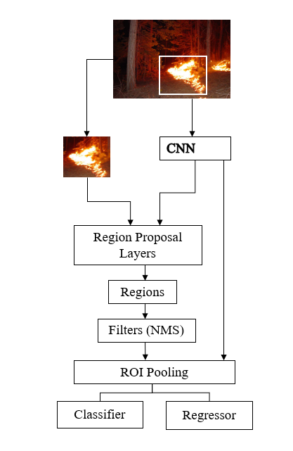

Fig. 9: Working of RCNN

**4. Results**

The classification type of the model is binary. The model was able to differentiate between images with and without fire with an accuracy of 97.29%. The accuracy of the Bluetooth and RTH sensors depend entirely on the calibration of those respective devices. The frame quality also depends upon the quality of the input image provided. 5MP camera used for taking real-time input in case of rising threat levels.

Table. 1

|  |  |
| --- | --- |
| Classifiers | Training Accuracy (in %) |
| CNN | 90.03 |
| Fully Connected CNN Layers | 94.69 |
| CNN | 97.29 |

From the Table. 1. It can be inferred that RCNN gives significantly better accuracy than CNN layers.

The model works perfectly with the calibrated devices. The high sensitivity to heat and humidity was achieved and thus improving overall results while the performance of functional evaluation of the prototype.

**5. Conclusion**

This system effectively detects and verifies the presence of fire in forest regions.The addition of Region proposals in CNN layers can result in better accuracy as well as faster execution. Our system can verify the presenceof fire in the forest with an accuracy of 97.29% from the RCNN model. This will help in the beginning phases of fire identification and assist with restricting the fire to restricted regions to prevent large-scale damage. This system focuses on observing the forests without steady human supervision.

**References**

[1]S. Ren, K. He, R. Girshick and J. Sun, "Faster R-CNN: Towards Real-Time Object Detection with Region Proposal Networks," in IEEE Transactions on Pattern Analysis and Machine Intelligence, vol. 39, no. 6, pp. 1137-1149, 1 June 2017, doi: 10.1109/TPAMI.2016.2577031.

[2] P. K. Singh and A. Sharma, "An insight to forest fire detection techniques using wireless sensor networks," 2017 4th International Conference on Signal Processing, Computing and Control (ISPCC), 2017, pp. 647-653, doi: 10.1109/ISPCC.2017.8269757.

[3] J. Zhang, W. Li, Z. Yin, S. Liu and X. Guo, "Forest fire detection system based on wireless sensor network," 2009 4th IEEE Conference on Industrial Electronics and Applications, 2009, pp. 520-523, doi: 10.1109/ICIEA.2009.5138260.

[4] Y. Liu, Y. Liu, H. Xu and K. L. Teo, "Forest fire monitoring, detection and decision making systems by wireless sensor network," 2018 Chinese Control And Decision Conference (CCDC), 2018, pp. 5482-5486, doi: 10.1109/CCDC.2018.8408086.

[5] J.Seebamrungsat, S. Praising and P. Riyamongkol, "Fire detection in the buildings using image processing," 2014 Third ICT International Student Project Conference (ICT-ISPC), 2014, pp. 95-98, doi: 10.1109/ICT-ISPC.2014.6923226.

[6] Mingyi Zhu and Jiamin Zhang, "Design of fire detection and alarm system based on intelligent neural network," 2011 3rd International Conference on Computer Research and Development, 2011, pp. 139-142, doi: 10.1109/ICCRD.2011.5764264.

[7] N. Chowdhury, D. R. Mushfiq and A. E. Chowdhury, "Computer Vision and Smoke Sensor Based Fire Detection System," 2019 1st International Conference on Advances in Science, Engineering and Robotics Technology (ICASERT), 2019, pp. 1-5, doi: 10.1109/ICASERT.2019.8934458.

[8] H. Liu, S. Li, L. Gao and T. Wu, "About automatic fire alarm systems research," 2010 2nd IEEE International Conference on Information Management and Engineering, 2010, pp. 419-421, doi: 10.1109/ICIME.2010.5477835.

[9] A. Mahgoub, N. Tarrad, R. Elsherif, A. Al-Ali and L. Ismail, "IoT-Based Fire Alarm System," 2019 Third World Conference on Smart Trends in Systems Security and Sustainablity (WorldS4), 2019, pp. 162-166, doi: 10.1109/WorldS4.2019.8904001.

[10] O. Kwon, S. Cho and S. Hwang, "Design and Implementation of Fire Detection System," 2008 Advanced Software Engineering and Its Applications, 2008, pp. 233-236, doi: 10.1109/ASEA.2008.49.